Step 1: Click on the login menu item on the Texas Justice Court Training Center’s website (https://www.tjctc.org)
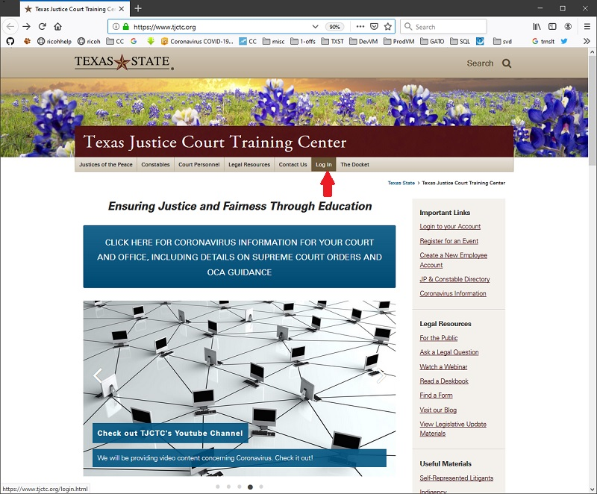

Step 2: Login with your UserID and Password
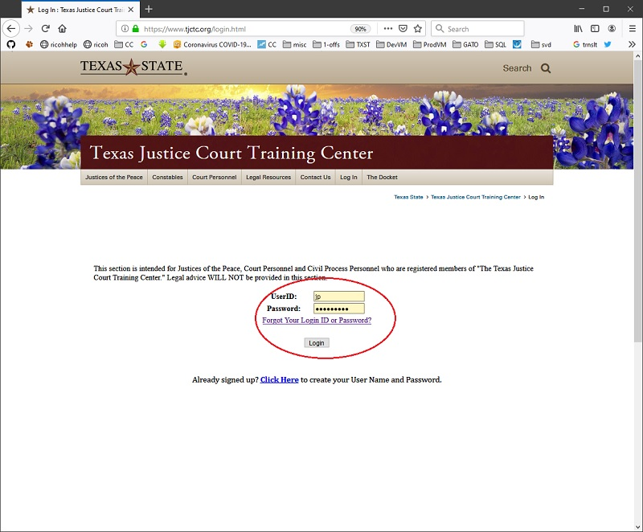

Step 3: Select the “View/Edit Student Info” menu option under My Information.
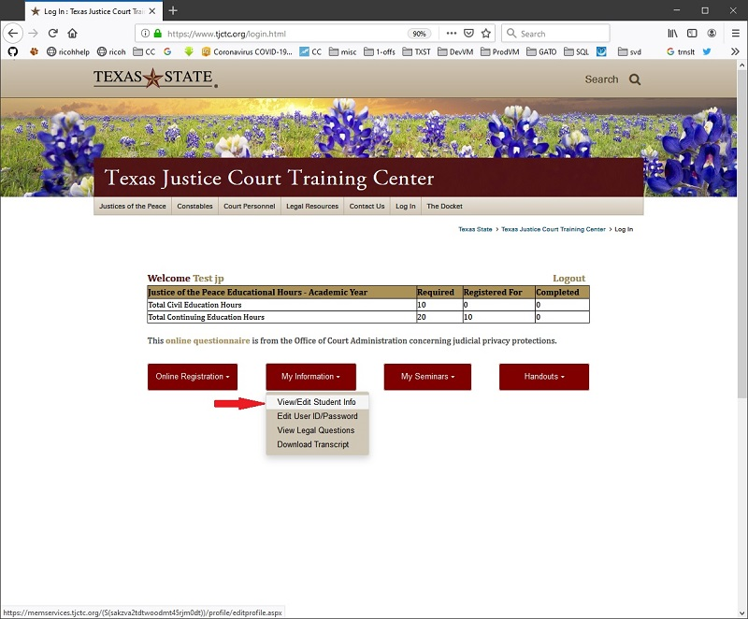

Step 4: Enter the Alternate Email address you wish to receive our newsletters and alerts and select the Yes option for Use Alternate Email For Newsletter
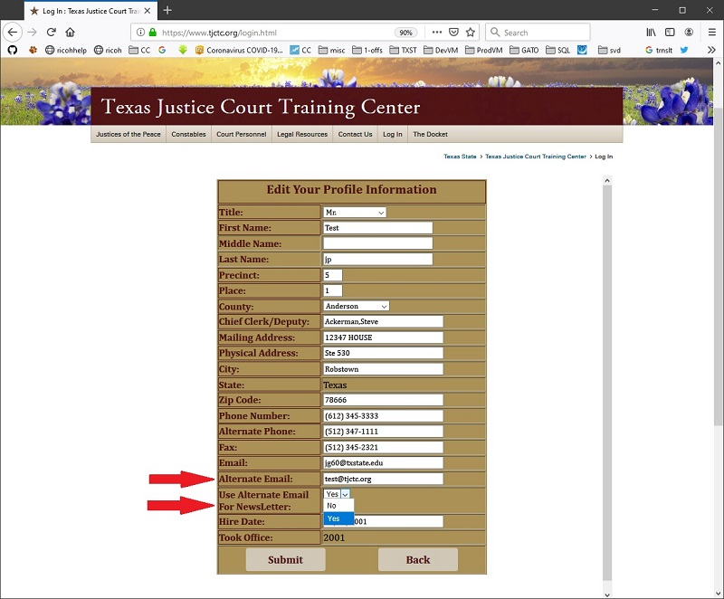

Step 5: Click the Submit button
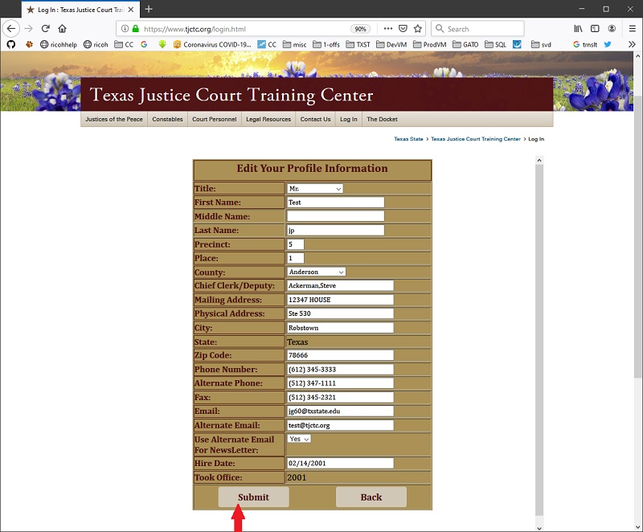

Now all our newsletters, updates and alerts will be sent to your alternate email address. You will still receive system emails, Legal Board Alerts, Invoices, Confirmation Letters etcetera, at the primary email address you have listed.
If you have any concerns, comments or questions please contact Jeff Grajek at jg60@txstate.edu or by phone at 512.347.9927 ext. 202

